The Cell Cycle – Growth, Division, and Life

Your body is not a static thing. It is a whirlwind of activity. Every second of every day, millions of cells in your body are dividing. Some are replacing skin cells you shed. Others are making new blood cells. Still others are repairing a cut you did not even notice. Yet most people go through life without ever considering the incredible, choreographed dance of the cell cycle that keeps them alive.
Biology is not merely a subject taught in classrooms. It is the study of life in motion. From the fertilized egg that became you — which divided again and again — to the stem cells that repair your organs, from bacteria that double every 20 minutes to the precise divisions that create sperm and eggs, the cell cycle governs every aspect of growth, reproduction, and survival. Understanding the cell cycle means understanding how life continues — and how it sometimes goes wrong.
This reading material explores the phases of the cell cycle, the differences between cell division in prokaryotes and eukaryotes, the unique processes of meiosis that create genetic diversity, and the vital roles of mitosis and meiosis in living organisms.

Part 1: What Is the Cell Cycle and Why Does It Matter?

Definition of the Cell Cycle
The cell cycle is the series of events that takes place in a cell leading to its division and duplication. It is the life cycle of a cell — from its origin after division of a parent cell to its own division into two daughter cells.

The Central Idea: A Cell's Life Has Phases
Just as a human life has stages (birth, childhood, adulthood, reproduction), a cell's life follows a predictable sequence. The cell cycle is not random. It is tightly regulated by control points (checkpoints) that ensure everything is ready before the cell commits to division.

Why the Cell Cycle Matters in Biology
Aspect | Explanation | Examples
Growth | Organisms get larger because cells divide, not because individual cells grow indefinitely | A child grows into an adult  through trillions of cell divisions
Repair | Damaged tissues are replaced by new cells produced through division | Healing a cut; regenerating a liver  after injury
Reproduction | Single-celled organisms divide to reproduce; multicellular organisms produce gametes (sperm and eggs) through a special type of division | Bacteria dividing; human  reproduction
Health | Cancer is a disease of uncontrolled cell cycle | Tumors form when cells divide  without regulation
Genetics | The cell cycle ensures DNA is copied exactly and distributed correctly | Preventing mutations; maintaining chromosome number

Part 2: The Phases of the Cell Cycle (Interphase, M-Phase, and Cytokinesis)
The eukaryotic cell cycle is divided into two major periods: Interphase (when the cell grows and prepares) and M-phase (when the cell divides). Cytokinesis is the final separation.

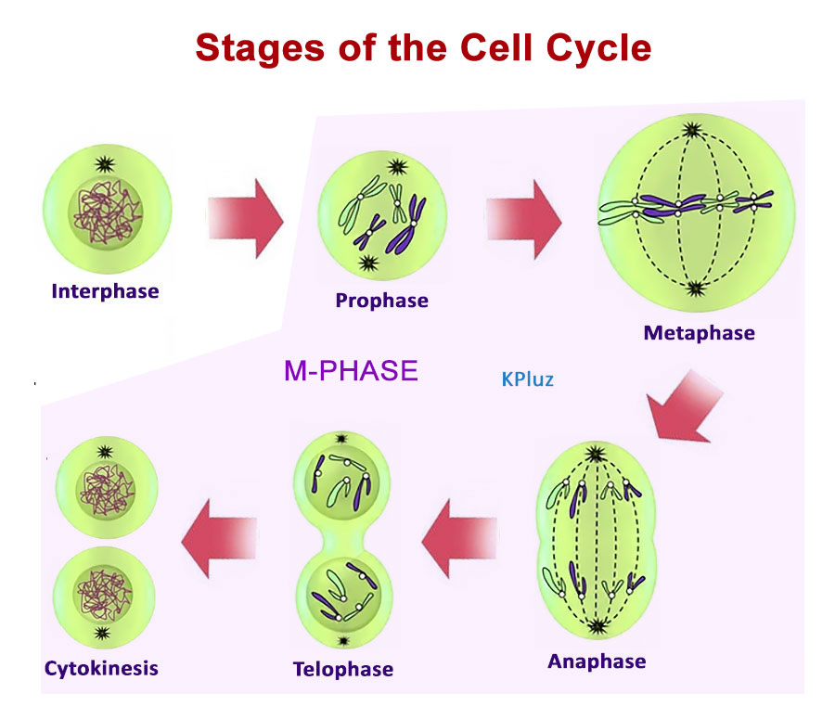

Phase 1: Interphase (The Preparation Stage)
Interphase is NOT a "resting" phase. It is the most active part of the cell's life. The cell grows, performs its normal functions, and prepares for division.
Stage | Full Name | What Happens | Duration
G1 Phase | Gap 1 (First Growth) | Cell grows physically; produces new proteins and organelles; performs its normal cellular functions | ~10 hours (varies)
S Phase | Synthesis Phase | DNA replication occurs — each chromosome is copied to produce two identical sister chromatids | ~8 hours
G2 Phase | Gap 2 (Second Growth) | Cell continues to grow; produces proteins needed for mitosis; checks that DNA replication was error-free | ~4 hours
Key point for students: The cell does NOT divide during interphase. It is preparing TO divide.

Phase 2: M-Phase (Mitosis + Cytokinesis)
The M-phase (Mitosis phase) is when the cell actually divides. It is the shortest part of the cell cycle.

Mitosis (Division of the Nucleus)
Mitosis is divided into four stages. Use the table below to draw each stage.
Stage | Name | What Happens | Diagram Description
Prophase | First phase | Chromosomes condense and become visible; nuclear envelope breaks down; spindle fibers form | Draw condensed X-shaped chromosomes; nuclear membrane disappearing
Metaphase | Alignment phase | Chromosomes line up along the metaphase plate (equator/middle of the cell); spindle fibers attach to centromeres | Draw chromosomes lined up in a single row across the center
Anaphase | Separation phase | Sister chromatids are pulled apart to opposite poles of the cell; each becomes a separate chromosome | Draw V-shaped chromosomes moving to opposite ends
Telophase | Final phase | Chromosomes arrive at poles; nuclear envelopes reform; chromosomes decondense | Draw two new nuclei forming; chromosomes becoming less visible

Cytokinesis (Division of the Cytoplasm)
Cytokinesis is the physical separation of the cytoplasm into two daughter cells. It occurs differently in animal and plant cells.
Cell Type | Cytokinesis Method | Description
Animal cells | Cleavage furrow | A ring of actin filaments contracts, pinching the cell membrane inward until the cell splits in two
Plant cells | Cell plate formation | Vesicles from the Golgi apparatus fuse at the equator, forming a new cell wall and membrane between the two new cells

Control Points (Checkpoints) of the Cell Cycle
The cell cycle has three major checkpoints that act like quality control inspectors. If conditions are not met, the cycle stops.
Checkpoint | Location | What Is Checked | What Happens If Failed
G1 Checkpoint (Restriction point) | End of G1 phase | Is cell big enough? Are nutrients available? Is DNA undamaged? | Cell stops cycling or enters G0 (non-dividing state)
G2 Checkpoint | End of G2 phase (before mitosis) | Is DNA fully replicated? Is DNA damage repaired? | Cell pauses mitosis; attempts repair or triggers self-destruction (apoptosis)
M Checkpoint (Spindle checkpoint) | During metaphase (before anaphase) | Are all chromosomes properly attached to spindle fibers? | Cell waits until all attachments are correct
Real-world connection: Cancer occurs when checkpoints fail. Damaged cells divide when they should not. Many chemotherapy drugs work by forcing cancer cells into checkpoint arrest, causing them to die.

Part 3: Cell Division in Prokaryotic vs. Eukaryotic Cells
Prokaryotes (bacteria and archaea) divide very differently from eukaryotes. Understanding these differences helps explain why antibiotics work and how life evolved.

Prokaryotic Cell Division: Binary Fission
Prokaryotes have no nucleus and no membrane-bound organelles. Their cell cycle is much simpler.
Feature | Binary Fission (Prokaryotes)
Number of stages | 3 simple steps (not named phases like mitosis)
Nucleus involved? | No — DNA is in the nucleoid region
Spindle fibers? | No
Process | 1. DNA replicates (circular chromosome copies itself)  2. Cell elongates, pulling the two DNA copies apart  3. Cell membrane pinches inward, dividing the cell into two
Time | Can be as short as 20 minutes (E. coli)

Eukaryotic Cell Division: Mitosis and Meiosis
Eukaryotes have complex, linear chromosomes inside a nucleus. They use mitosis for growth/repair and meiosis for sexual reproduction.
Feature | Mitosis (Eukaryotes) | Meiosis (Eukaryotes)
Number of divisions | One division | Two divisions (Meiosis I and  Meiosis II)
Number of daughter cells | 2 | 4
Chromosome number in daughter cells | Same as parent (diploid → diploid) | Half of parent (diploid → haploid)
Genetic variation | None (clones) | High (crossing over +  independent assortment)
Where it occurs | Somatic (body) cells | Germ cells (ovaries/testes)
Purpose | Growth, repair, regeneration | Production of gametes (sperm/  eggs) for reproduction

Comparison of Prokaryotic and Eukaryotic Cell Division
Step | Prokaryotic Binary Fission (Simple) | Eukaryotic Mitosis (Complex)
Starting cell | Parent cell | Parent cell (diploid)
Step 1 | DNA replicates | DNA replicates
Step 2 | Cell elongates | Mitosis occurs (Prophase → Metaphase →  Anaphase → Telophase)
Step 3 | Cell divides | Cytokinesis occurs
Final result | Two identical cells (prokaryotic clones) | Two identical cells (eukaryotic clones)

Part 4: Crossing Over and Recombination in Meiosis
Meiosis produces genetic variation. Without variation, evolution could not happen, and all offspring would be identical clones. The two main sources of variation in meiosis are crossing over and independent assortment. This section focuses on crossing over and recombination.

What Is Crossing Over?
Crossing over is the exchange of genetic material between homologous chromosomes during Prophase I of Meiosis I.

The Process of Crossing Over
Step | What Happens | Diagram Description
1 | Homologous chromosomes (one from mother, one from father) pair up tightly. This pairing is called synapsis. | Draw two different colored chromosomes  (e.g., red = maternal, blue = paternal) lying  next to each other
2 | The paired homologous chromosomes form a structure called a bivalent (or tetrad — four chromatids total). | Draw the pair with each chromosome  duplicated (two sister chromatids each) —  total 4 chromatids
3 | At points called chiasmata (singular: chiasma), the non-sister chromatids break at corresponding locations. | Draw X-shaped cross points where  chromatids touch and swap
4 | The broken segments are exchanged between homologous chromosomes. This exchange is recombination. | Draw the chromatids now with mixed  colors — red segment on blue chromosome,  blue segment on red chromosome
5 | The chromosomes separate, but each now contains a mix of maternal and paternal genes. | Draw the final four chromatids, each with  unique color patterns

Why Crossing Over Creates Genetic Variation
Before crossing over, each chromosome was purely maternal or purely paternal. After crossing over, each chromosome is a mosaic — part maternal, part paternal.
Example: Chromosome 11 carries genes for eye color, hair texture, and blood type.
- Before crossing over: Maternal chromosome 11 has (brown eyes + curly hair + type A blood); Paternal chromosome 11 has (blue eyes + straight hair + type O blood)
- After crossing over: One chromosome might have (brown eyes + straight hair + type O blood) — a combination that existed in NEITHER parent

Recombination Frequency
Genes that are farther apart on a chromosome are more likely to be separated by crossing over. Scientists use recombination frequencies to map the locations of genes on chromosomes.

Crossing Over vs. Independent Assortment (Quick Comparison)
Mechanism | When It Occurs | What It Does | Result
Crossing over | Prophase I | Exchanges segments between homologous chromosomes | New allele combinations on the SAME chromosome
Independent assortment | Metaphase I | Random alignment of homologous chromosome pairs | Random mixing of which chromosome goes to which gamete
Together, crossing over and independent assortment make it virtually impossible for two gametes (except identical twins) to be genetically identical.

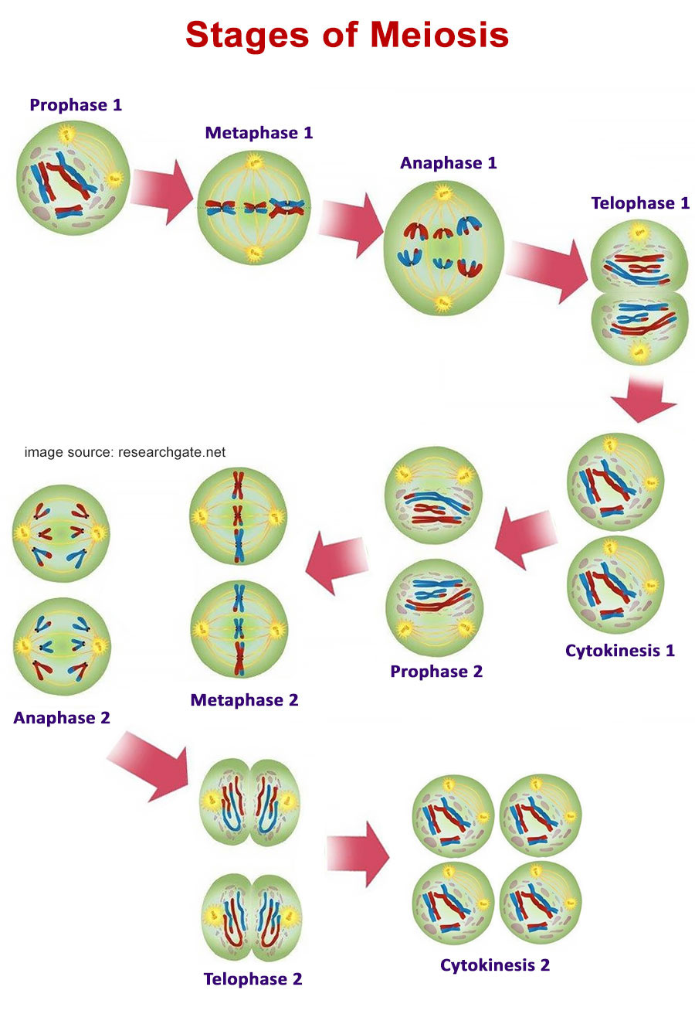

Part 5: The Significance of Mitosis and Meiosis

Significance of Mitosis: Growth, Repair, and Regeneration
Function | Explanation | Example
Growth | Multicellular organisms increase in size by adding more cells through mitosis | A fertilized egg (one cell) → trillions  of cells in an adult human
Repair | Damaged or dead cells are replaced by new cells produced by mitosis | Skin cells replace themselves every  2-4 weeks; liver cells regenerate  after injury
Regeneration of damaged cells | Some organisms can regrow entire body parts through mitosis | Starfish regrow arms; lizards regrow  tails; humans regrow liver tissue
Asexual reproduction | Some organisms reproduce entirely by mitosis | Hydra (budding); yeast (budding);  many plants (cuttings)
Key point: Mitosis produces genetically identical daughter cells. This is essential because your skin cells must be identical to the cells next to them — not a mixture of traits.

Significance of Meiosis: Reproduction and Genetic Diversity
Function | Explanation | Example
Production of gametes | Meiosis produces haploid sperm and egg cells | Human males produce ~1,000 sperm  per second through meiosis; females  produce eggs (oocytes)

Maintaining chromosome number | When sperm (n) fertilizes egg (n), the zygote has 2n — the correct number for the species | Human sperm (23 chromosomes) +  human egg (23 chromosomes) =  zygote (46 chromosomes)
Genetic variation | Crossing over and independent assortment create unique combinations of alleles | No two siblings (except identical twins)  are genetically identical, even with the  same parents
Evolution | Variation provides raw material for natural selection | Populations with more genetic variation  are more likely to survive environmental  changes

Comparison Table: Mitosis vs. Meiosis — When and Why
Aspect | Mitosis | Meiosis
Where | All body tissues (skin, liver, bone, etc.) | Ovaries (females) and testes (males)
When | Continuously throughout life | Begins at puberty; continues until death  in males; ends at menopause in females
Why | To produce identical cells for growth and repair | To produce unique gametes for sexual  reproduction
Result | Two diploid daughter cells identical to parent | Four haploid daughter cells genetically  different from parent
Role in healing | Direct — new cells replace damaged ones | Indirect — only for producing gametes  that could lead to a new organism
Cancer risk | High — errors in mitosis control lead to tumors | Low — meiosis occurs only in specialized  cells

Key Terms
Term | Definition
Cell cycle | The series of events from one cell division to the next; includes  interphase, mitosis, and cytokinesis
Interphase | The period of cell growth and preparation for division; includes G1, S,  and G2 phases
Mitosis | Division of the nucleus into two genetically identical nuclei
Cytokinesis | Division of the cytoplasm into two separate daughter cells
Checkpoint | A control point in the cell cycle where conditions are assessed before  proceeding
Binary fission | The method of cell division used by prokaryotes (bacteria and archaea)
Crossing over | Exchange of genetic material between homologous chromosomes  during Prophase I of meiosis
Recombination | The process by which genetic material is rearranged, producing new combinations of alleles
Chiasma (pl. chiasmata) | The physical point where crossing over occurs between non-sister  chromatids
Homologous chromosomes | A pair of chromosomes (one maternal, one paternal) that carry the  same genes at the same loci
Sister chromatids | Two identical copies of a single chromosome, held together by a  centromere, produced during DNA replication
Diploid (2n) | A cell that contains two complete sets of chromosomes (one from  each parent)
Haploid (n) | A cell that contains one complete set of chromosomes (gametes)

Review Questions
Responses should be written on a separate sheet of paper.
- List the three main phases of the cell cycle (interphase, M-phase, and cytokinesis). For each phase, describe the major events that occur and state approximately how long the phase lasts relative to the total cell cycle.
- Name the three major checkpoints of the cell cycle. For each checkpoint, state:
  - Where it is located (which phase)
  - What condition is being checked
  - What happens if the condition is not met
- Differentiate cell division in prokaryotes and eukaryotes by completing the following table in your answer:
Feature | Prokaryotic Division (Binary Fission) | Eukaryotic Division (Mitosis)
Presence of a nucleus
Use of spindle fibers
Number of stages
Approximate time to complete
- Explain the process of crossing over and recombination in meiosis. Your answer must include:
  - Which phase of meiosis it occurs in (be specific)
  - The name of the structure formed when homologous chromosomes pair
  - The name of the points where crossing over occurs
  - Why crossing over results in genetic variation among offspring
- Describe the significance of mitosis in living organisms. Provide one specific example for each of the following:
  - Growth
  - Repair
  - Regeneration of damaged cells
- Describe the significance of meiosis in living organisms. Your answer must explain:
  - Why meiosis is essential for sexual reproduction
  - How meiosis maintains the correct chromosome number from generation to generation
  - Why genetic variation from meiosis is important for the survival of a species
- Application question: A student examines a cell under a microscope and observes that the chromosomes are lined up along the middle of the cell. In which stage of mitosis is this cell? What should happen next in the cell cycle?

